Confleezers Analysis Manual:

0 Movie Preprocessing

Open the large files in Fiji and determine the cropping (make sure that the vesicle does not go out of the cropping area).

Draw a rectangle, add it to the ROI manager, save the ROI as ‘movie_ROI.roi’

Then show the ‘List’ and transfer the values for x, width, y and height into the _info.csv

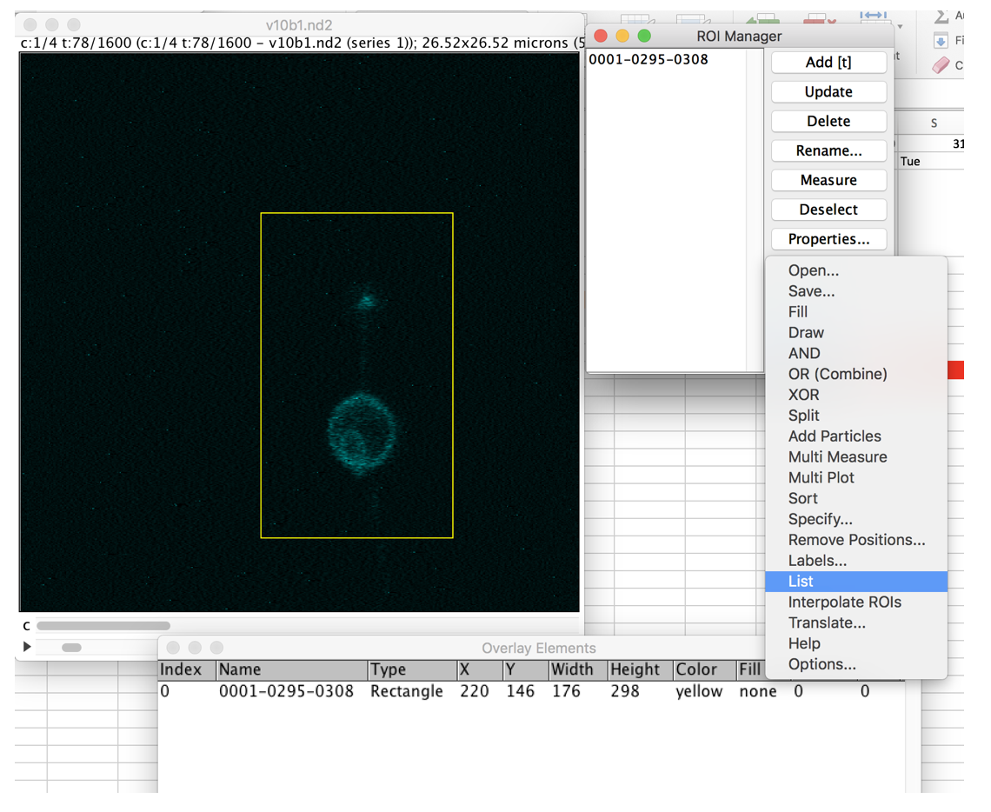

take the individual movies and open them in Fiji

Save them as .avi files

Take the avi files and put them in keynote, arrange them as a montage

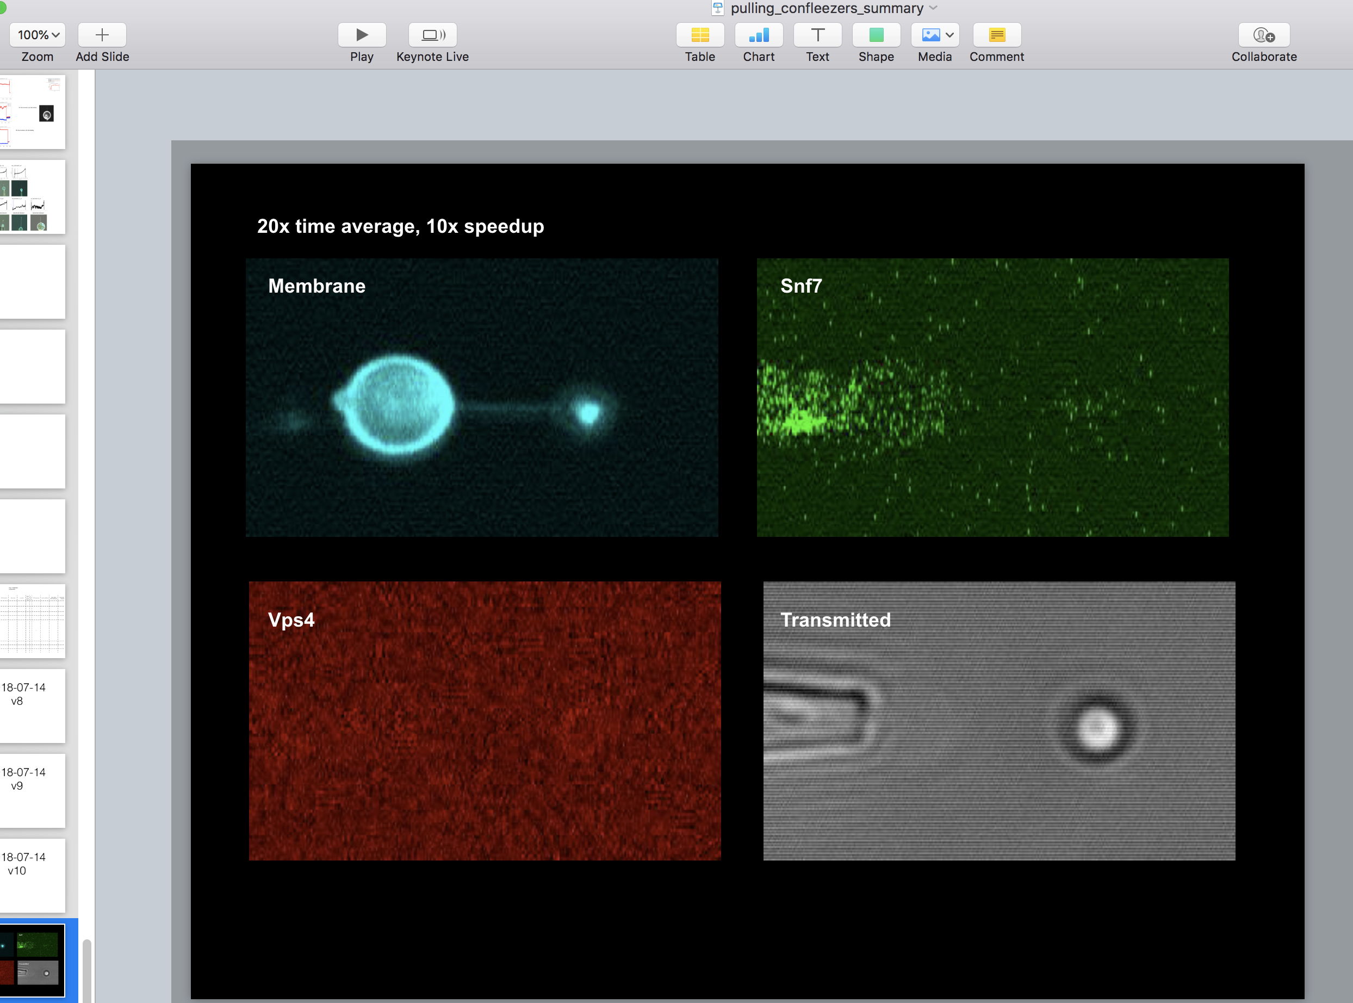

Use Quicktime to record a screencapture, right after you click ‘present’

Save the montage

For long movies that go over multiple 5Gb movies, use this:

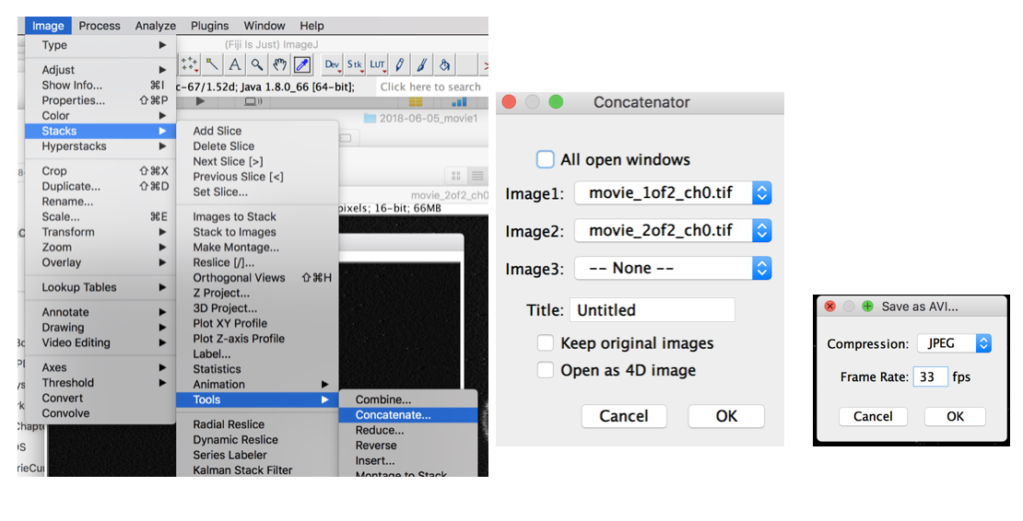

After they have been cut.

0.1 Make nice presentation movie out of the individual movies

* Rotate the images 90degrees to the right
* Label:
  + Choose the color of your label from the pallete
  + Go to Stacks, Label…,

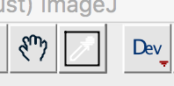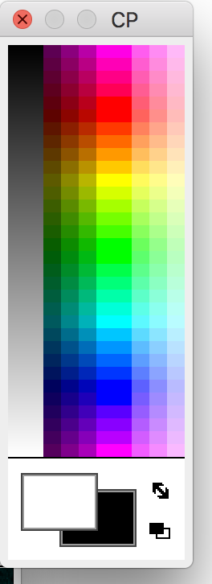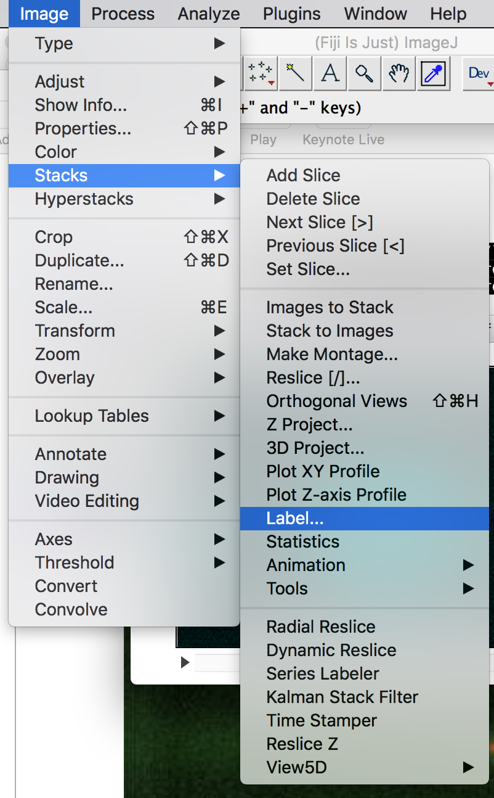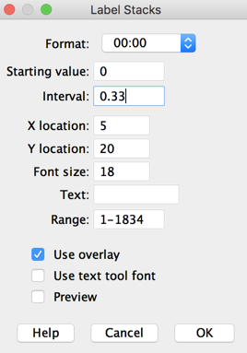

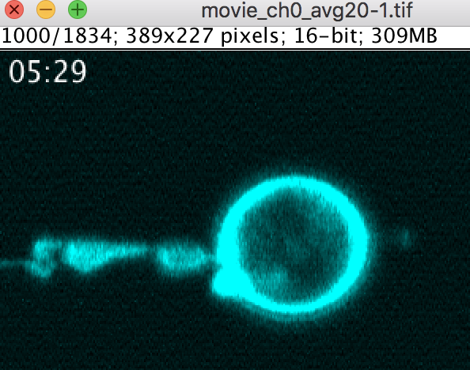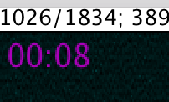

* **Fancy coloring: white, purple, white:**
  + Check the timing: t=0 is UV light
  + Color in white when there is no UV light
  + Color in Purple (third from left, lowest row) when there is UV light
  + **Starting value: movie_startTime_difference_UVstart_seconds**,-70.0
  + **Range: 0 to UVstart_frames_movie,600; white**
  + **Range: UVstart_frames_movie,600 to UVend_frames_movie,1531; purple**
  + Range: **UVend_frames_movie,1531 to end; white**
* Simple coloring: white
  + **Starting value: movie_startTime_difference_UVstart_seconds**,-70.0

Special case: v10; 1-1723: -70s, then every 0.333s

Then: 1723 to end, 503+100s = 600s

- put the individual movies into a keynote

- make them all start at the exact same time

- use the quicktime screen capture to take a movie of the whole screen

- quickly start the presentation and hit play for the movies

If you do that quickly enough you don’t have to postprocess the movie

If you have some keynote footage in the screencapture, crop it out using iMovie.

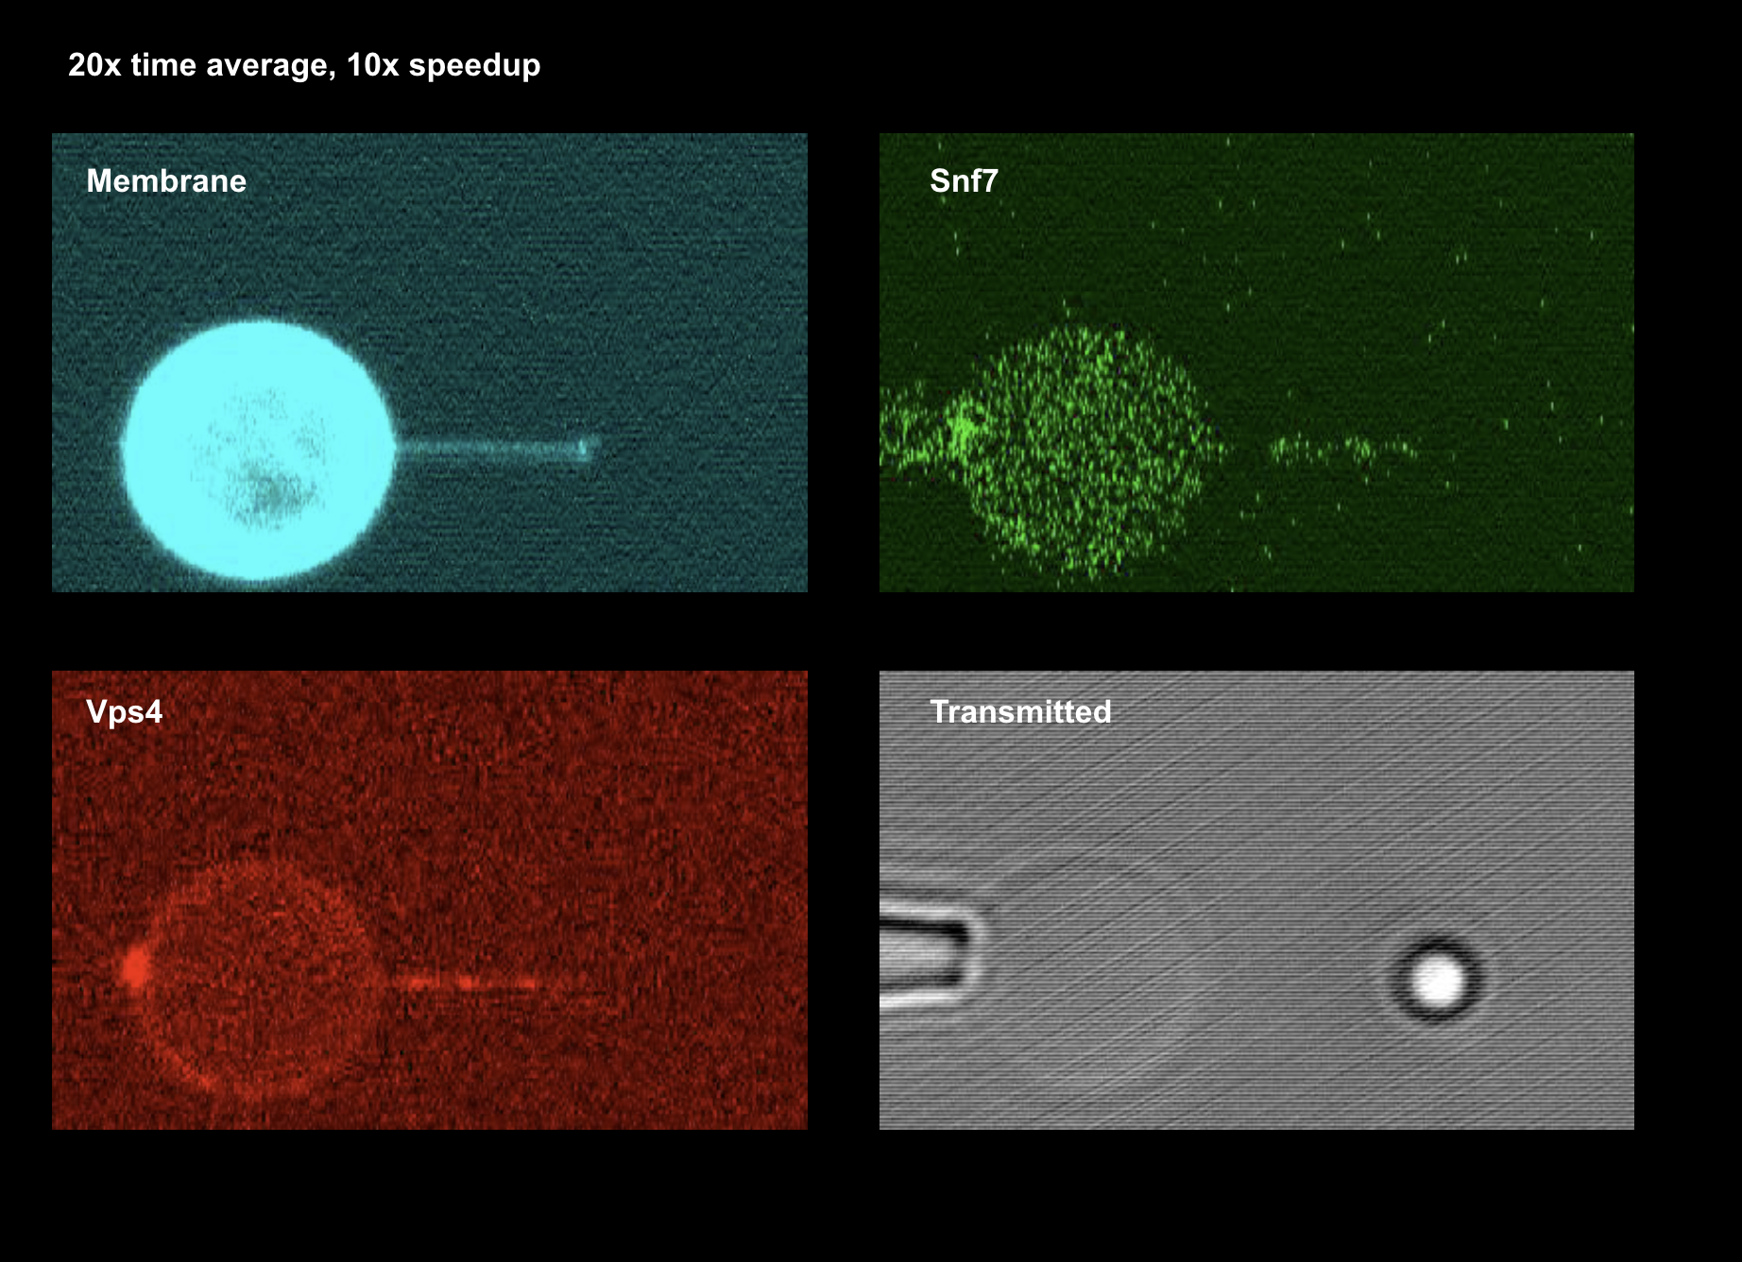

1 Timing

**UVstart_seconds_fftime**

**UVend_seconds_fftime**

These two parameters are manually recorded in the logbook during the experiment. Transfer the values from the logbook into the _info.csv

**movie_timestamp**

movie_startTime

open the raw movie in Fiji

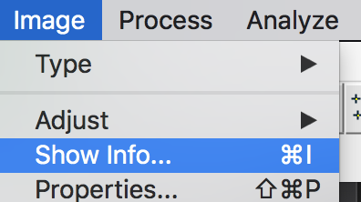

Go to Image -> Show Info…

In the text, find ‘TextInfoItem_96’ or similar

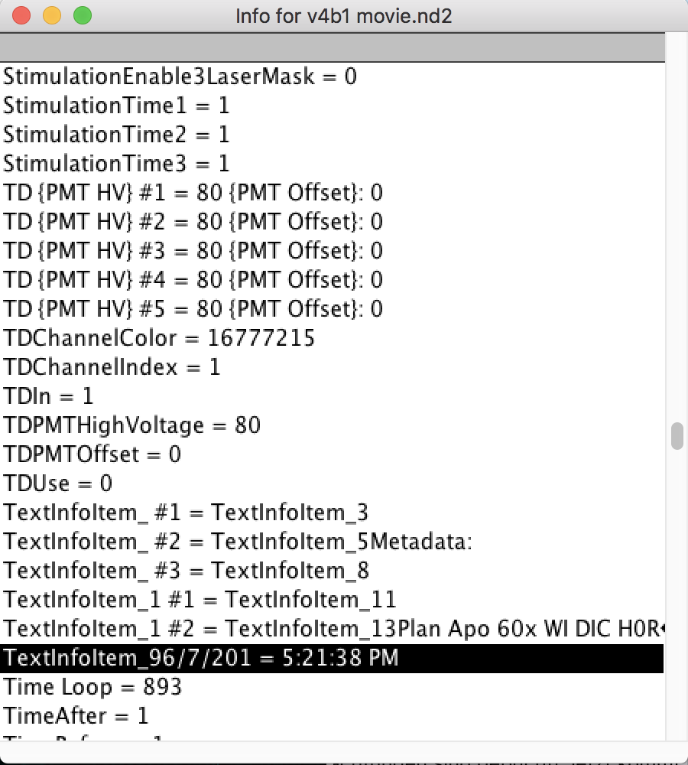

Copy the information into the _info.csv for this movie

Manually parse out the start date from what you find in the info text (using the known date of the experiment):

e.g.

TextInfoItem_96/7/201 = 5:21:38 PM

=>

2018-06-07 17:21:38

forceFile_startTime

use the notebook ***/confleezers_data_analysis/tube__1_timing_force_movie_UV.ipynb***

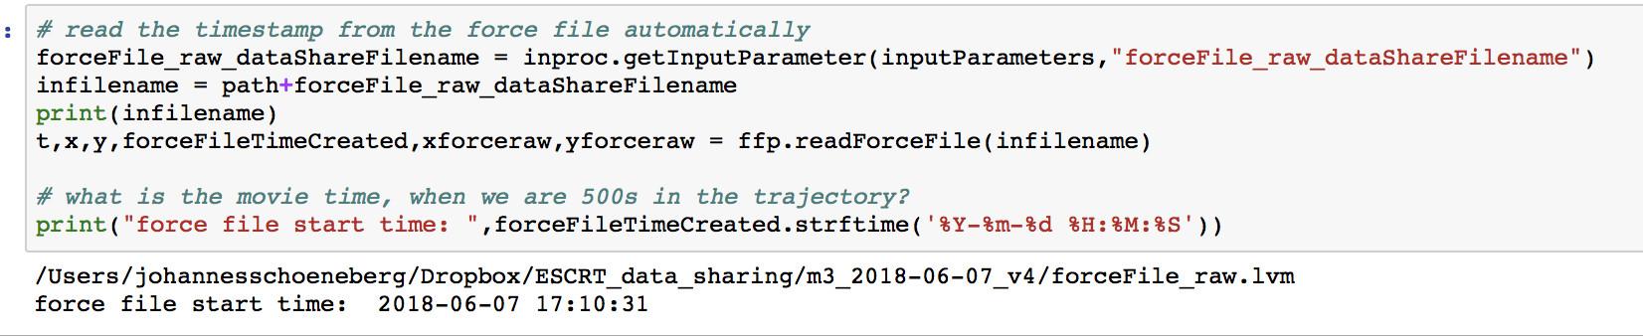

seconds_ffStart_to_movieStart

use the notebook ***/confleezers_data_analysis/tube__1_timing_force_movie_UV.ipynb***

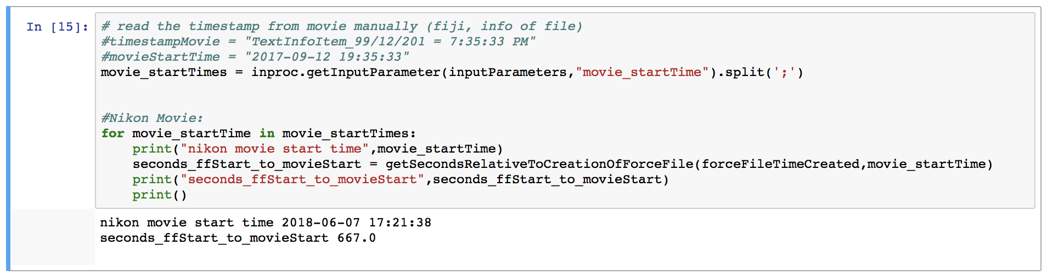

2 Force File Analysis

tube_break_seconds_fftime

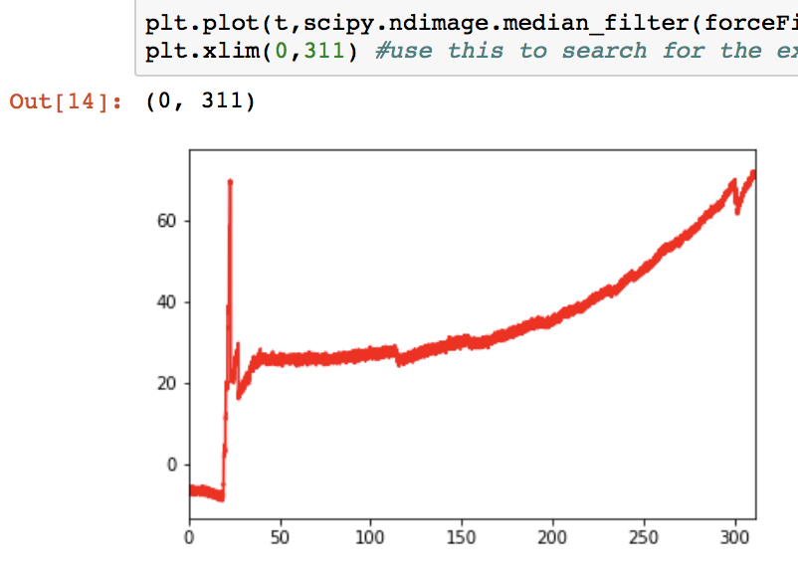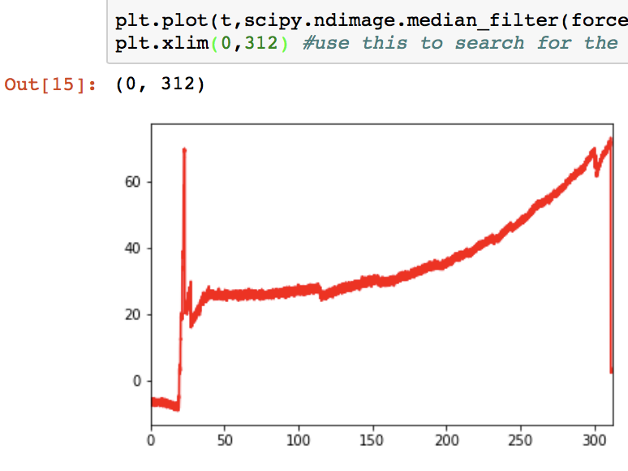

Find the time at which the tube breaks by manually cropping the xlimit of the plot

ffprocessing_zoomTime0

ffprocessing_zoomTime1

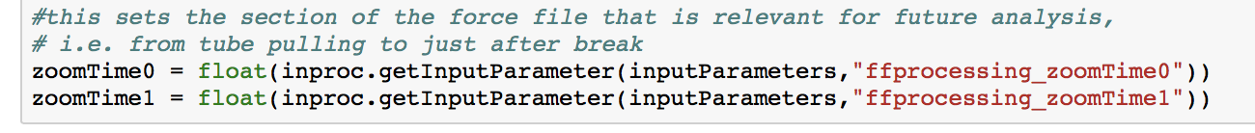

These parameters allow you to crop the force file e.g. in case the recording was not stopped in time and the relevant time has to be cropped out of a larger trajectory

ffprocessing_fitStart

ffprocessing_fitEnd

1. Take movie and process it with 0_analyzeMovie.ipynb
2. Take a rectangular selection in Fiji that encompasses the vesicle
3. Save that as an ROI
4. Save the cropped movie as a tiff and as an avi (30fps = 10x speedup)

3 Calculate Tube Vector

Have the following movies:

**From channel 0: (membrane channel)**

* The cropped vesicle debleached
* 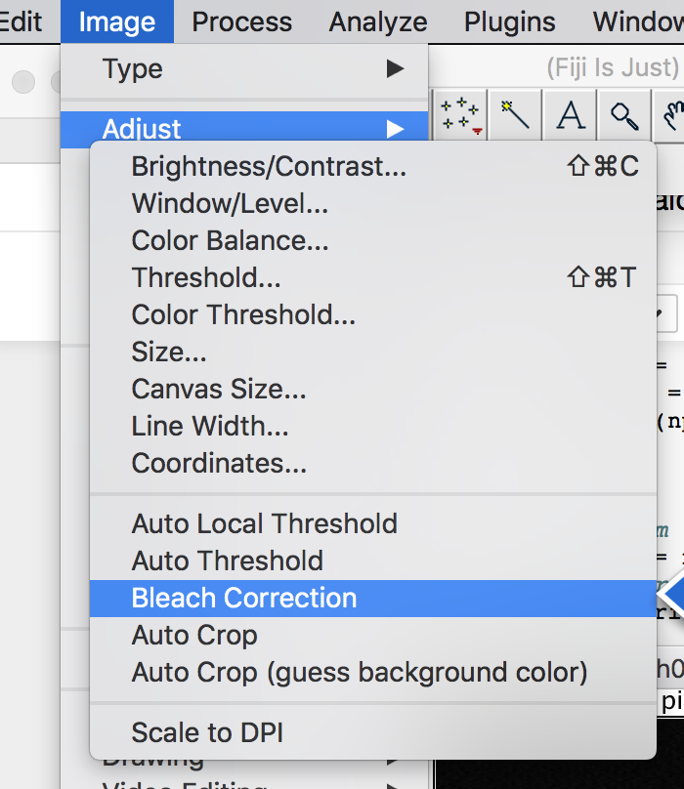 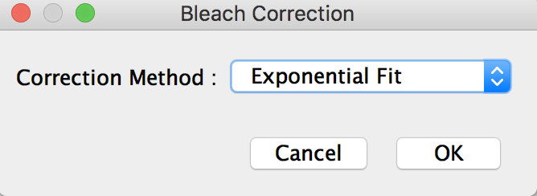
* The same and maxEntropy thresholded (auto) to find the vesicle

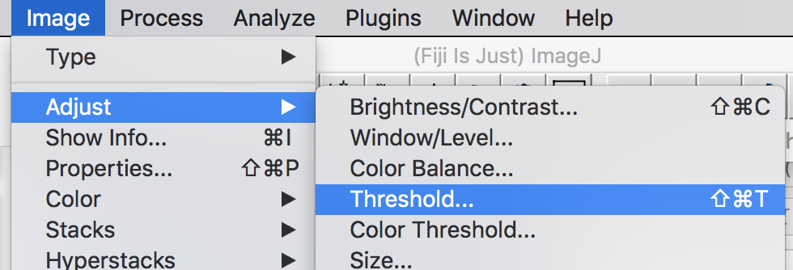

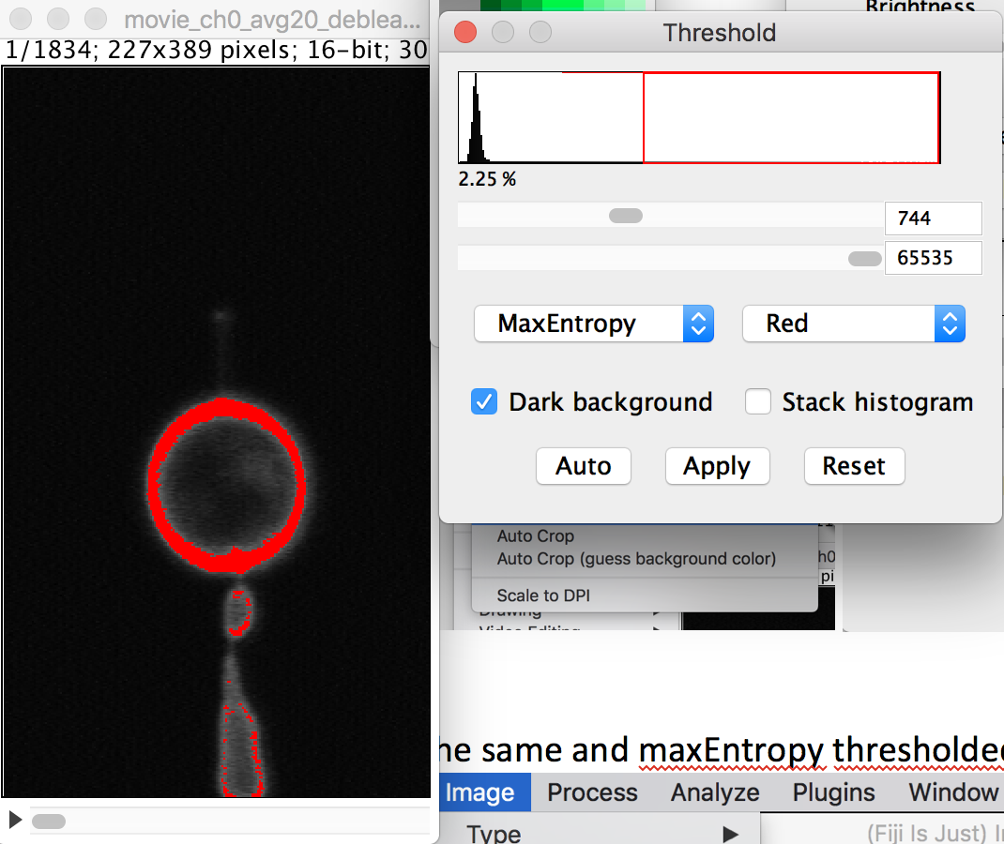 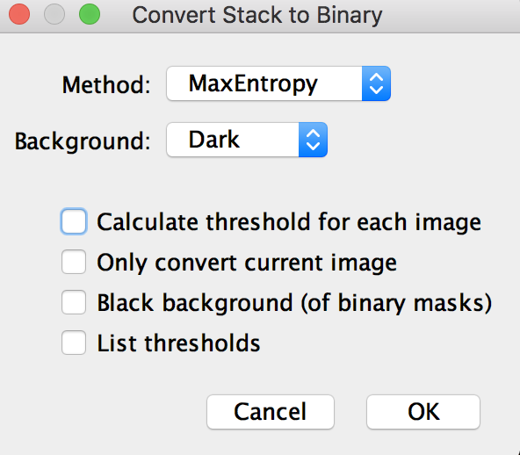 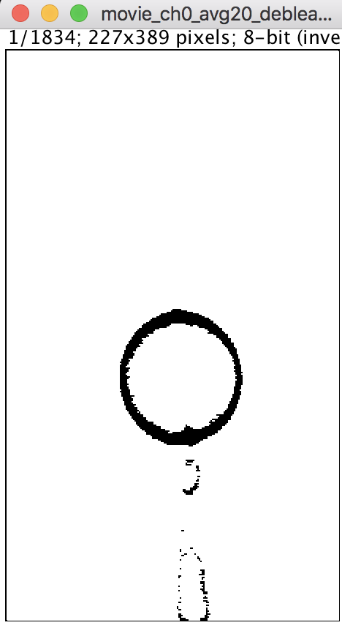

**From channel 3: (transmitted detector)**

* The cropped channel
* The same and maximum filteredwith 2px and yen Thresholded (auto)

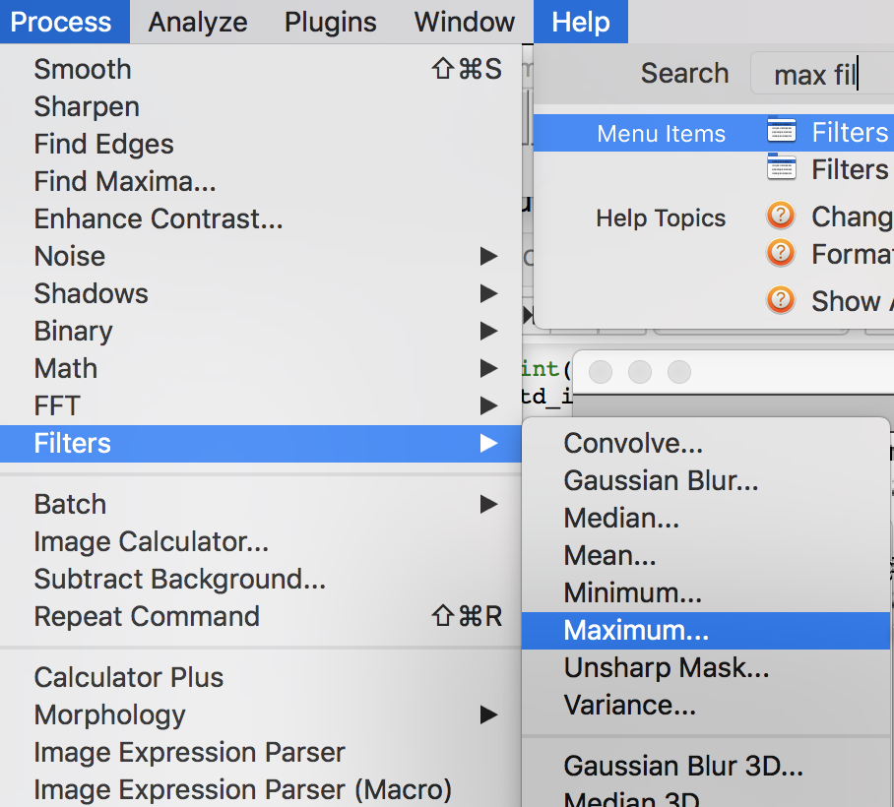 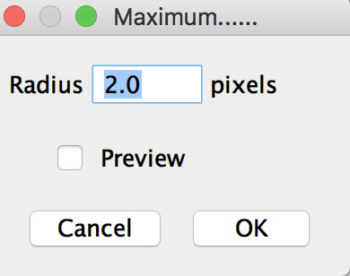 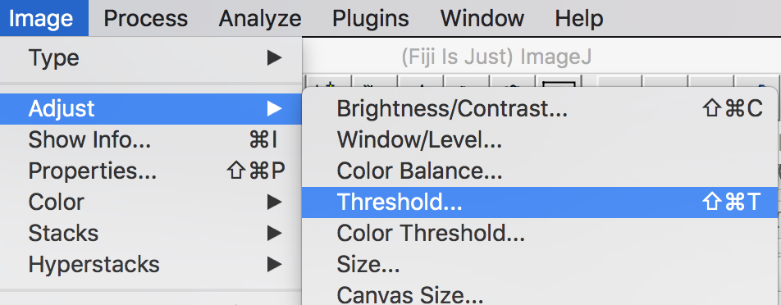 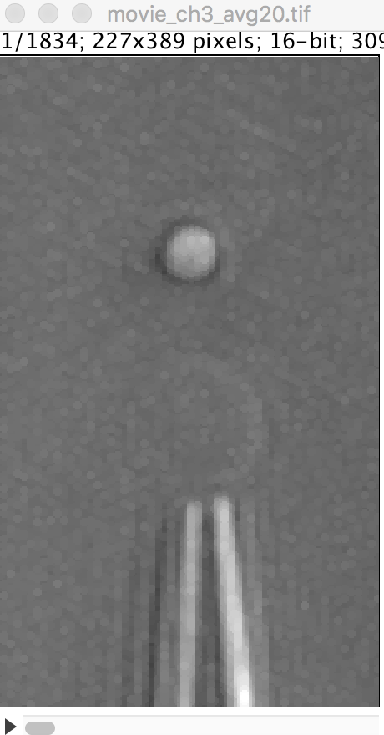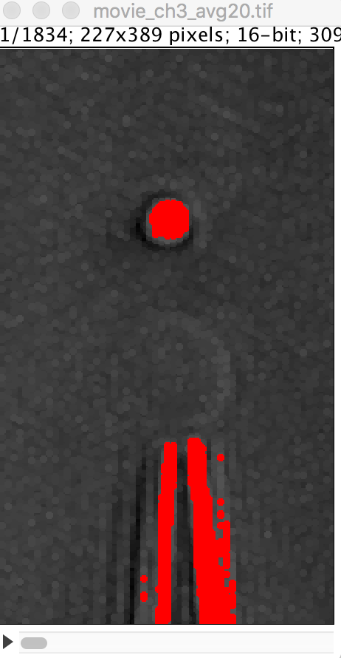 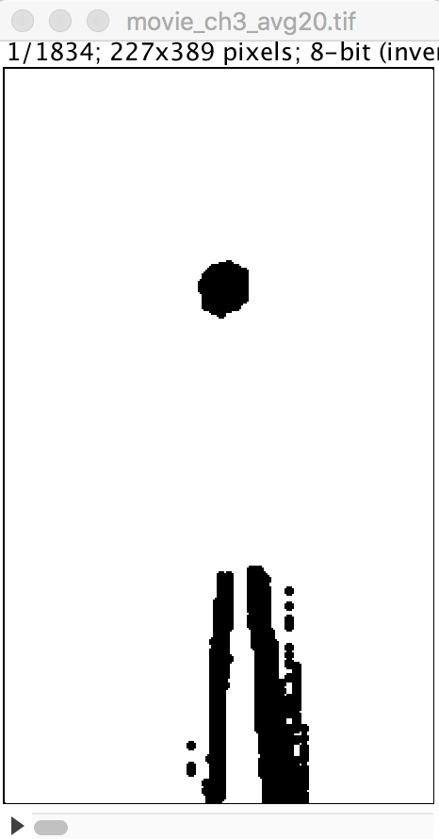

* find a good y value where the tube is ok throughout the movie, put that value into the script

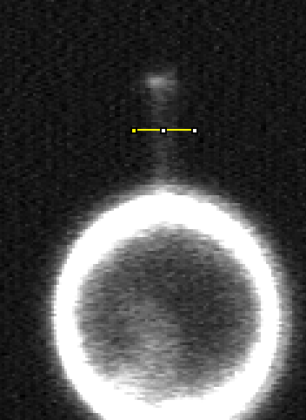

* tubeVector_tubemidpointY_px
  + this value is the starting point in y for the algorithm to try and find a tube signature from which it expands the tube automatically.
* tubeVector_beadAdditionalMargin_px
  + this value determines how many pixels away from the bead boundary you define the start of the tube. For example 5 px
* tubeVector_vesicleAdditionaMargin_px
  + this value determines how many pixels away from the vesicle boundary you define the start of the tube. For example 5px